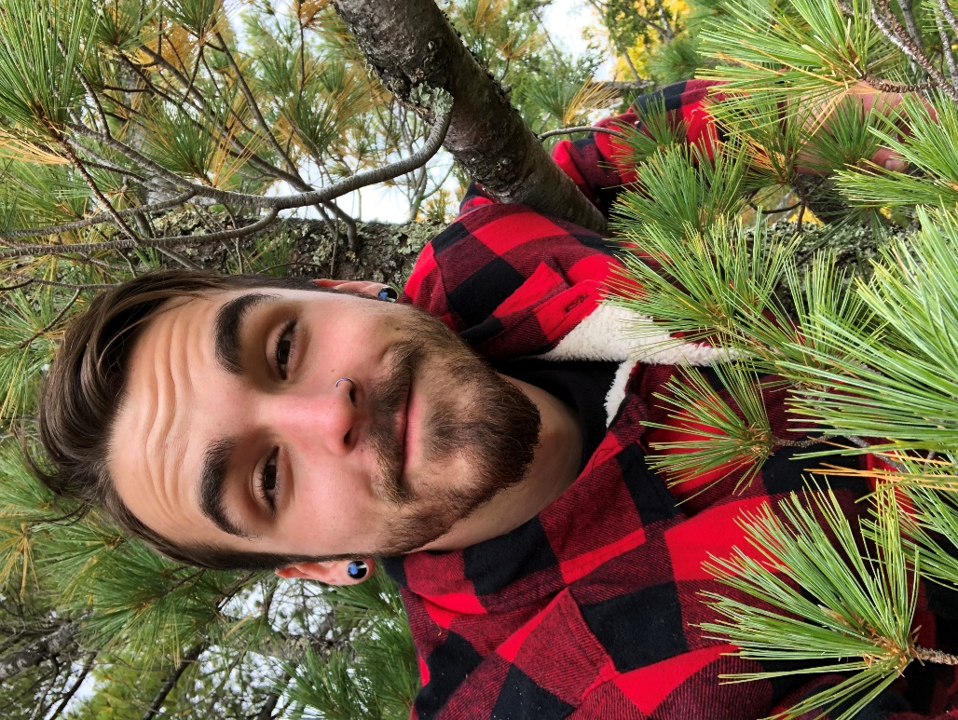 |  | Caden Reed  Botany Student
Profile  I am currently studying Botany full-time at Northern Michigan University, living off-grid near Big Bay, and working at Superior Culture part-time. I am looking for flexible hours and the ability to progress higher up. I am very social, friendly and love to help make new connections between people. I am hands-on, diligent and ready to learn any new skills.  Contact  PHONE:  (906) 362-2670  EMAIL:  reedcaden@gmail.com  Hobbies  Ultimate Frisbee  Backpacking  Drawing  Rock-hounding  Golf  Skiing  Botany  Mycology  Foraging  Cooking  Home-brewing  Herbalism/Natural Medicine  Conversation  Educating/Sharing Info |  | EDUCATION  Northern Michigan University  08/2016 – 12/2020  GPA: 3.05  Ultimate Frisbee Riptide, Conservation Crew, Founder of Decriminalize Nature Marquette  Swan Valley High School  09/2011 – 06/2015  500+ hours of community service, 3.5 GPA, honored blood donor, varsity soccer  WORK EXPERIENCE  Superior Culture  07/2019 - Current  Mow tees, cut trees down, clear saplings, trash duty, sod transferring  Marquette Golf Club Grounds  05/2018– 07/2019  Mow tees, cut trees down, clear saplings, trash duty, sod transferring  Double Trouble Rental Crew/Photo-booth  04/2019–Current  Set up and tear down of tents and stage sets, operating a photo-booth occasionally.  SKILLS

